PIZZA SALES SQL QUERIES  
A KPI

TOTAL REVENUE  
select SUM(total_price) as TOTAL_REVENUE from pizza_sales  
  
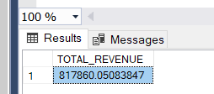

Average Order value: The average amount spent per oder

select SUM(total_price) / count(distinct order_id) as Avg_Order_Value from pizza_sales

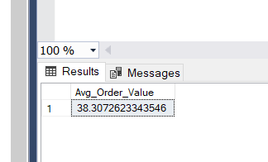

Total pizza sold sum of qunataties of all pizas sold

select sum(quantity) as total_pizza from pizza_sales

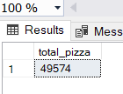

Total orders- total number of orders placed

select count(distinct(order_id)) as total_order from pizza_sales



Average Pizzas per order is no of pizzas per total orders

SELECT

CAST(SUM(quantity) AS DECIMAL(10,2)) /

CAST(COUNT(DISTINCT order_id) AS DECIMAL(10,2)) AS avg_pizza_order

FROM pizza_sales;

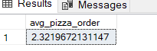

PROBLEM STATEMENT

CHARTS REQUIREMENT  
DAILY TREND FOR TOTAL ORDERS

Idemtify any patternss or fluctuuation in orders volumes

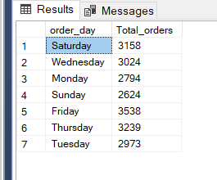

MOTHLY REQUIREMENT

FAILY MONTHLY TRENDSFOR TOTAL order

select DATENAME(MONTH,order_date) as order_day,COUNT(DISTINCT order_id) AS Total_orders from pizza_sales

Group BY DATENAME(MONTH,order_date)

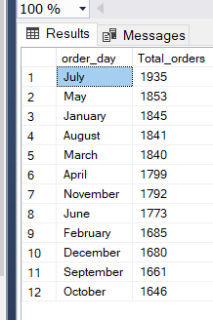

Percentage ofsales by Pizza Category

Select pizza_category,sum(total_price) * 100 /(SELECT sum(total_price) from pizza_sales) as Total_price from pizza_sales group by pizza_category

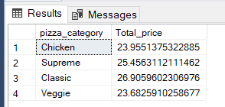

Total Pizzas Sold by Pizza Category

Total number of pizzas sold for each pizza category this chart sales performance of differnct piiza categories

select pizza_category,sum(quantity) as Total_Sales from pizza_sales group by pizza_category

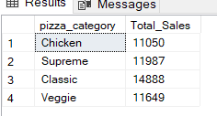

Top 5 pizza by sales

select top 5 pizza_name,sum(quantity) as Total_Sales from pizza_sales group by pizza_name

order by sum(quantity)

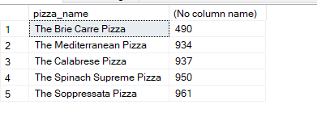

Top 5 pizza by orders

select top 5 pizza_name,count(distinct order_id) as Total_orders from pizza_sales group by pizza_name

order by sum(quantity)

